Mandatory Assignment 02 - 3. Semester spring 2015
You have a file, and would like to analyze it, but you miss the tool to do so.
So this assignment is to build a hexdump program, this is a program that read a file, and then display first the address in hexadecimal, then the letter in hexadecimal, there will be 16 characters pr line, after the hexadecimal notation there will be a ascii notation.

The display will look like this.
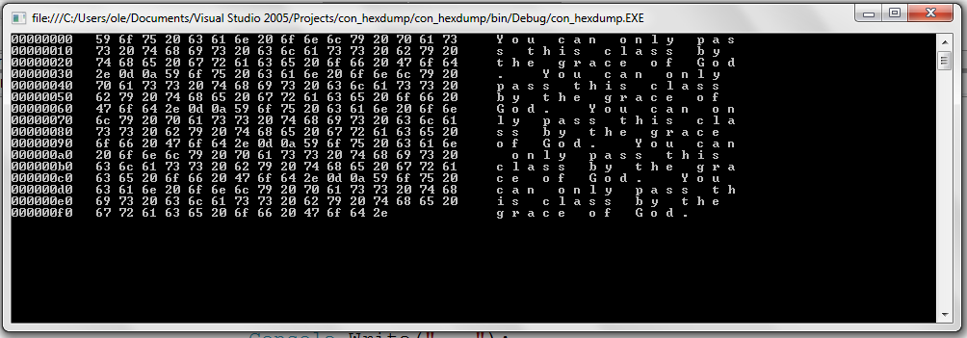

It is up to you if you want a console application or a windows application
The program has to be uploaded to the homepage, or at my email latest the 3. June at 23:29.
I believe that there is some who still owe the first assignment
Email : jens@klarskovpedersen.dk

Phone (if you got any question about the assignment) 43998786
Do not call me about the exam. There will come information later.

